**Assignment 1**

**Name: Apar Garg**

**Enrolment No: E17CSE112**

Target language (other than English) – Hindi

Corpus weblinks:-<https://tdildc.in/index.php?option=com_download&task=showresourceDetails&toolid=1418&lang=en>

Code and Screenshot of your outputs for-

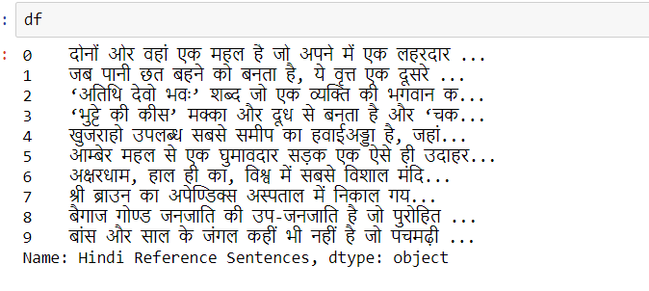

Tokenization

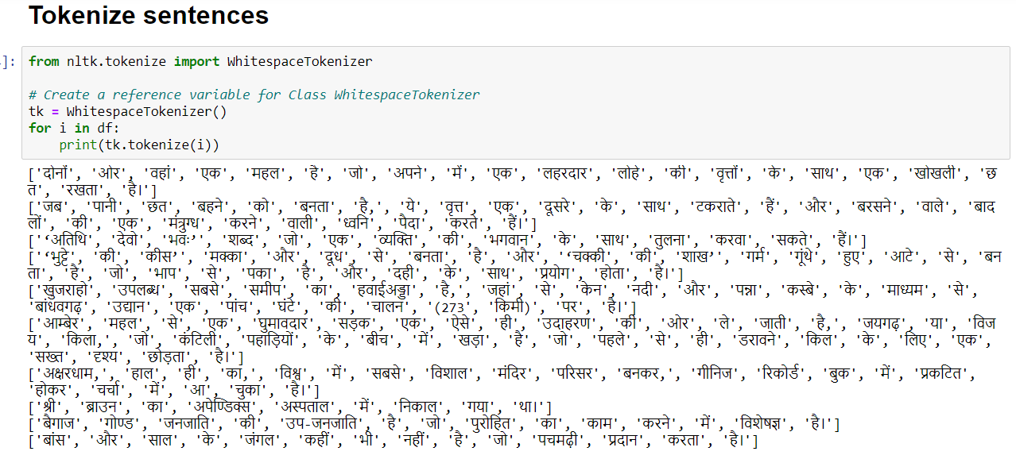

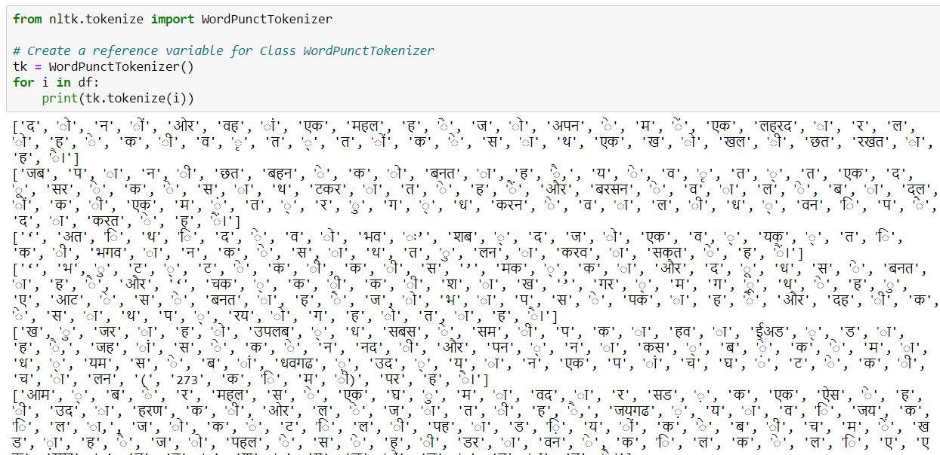

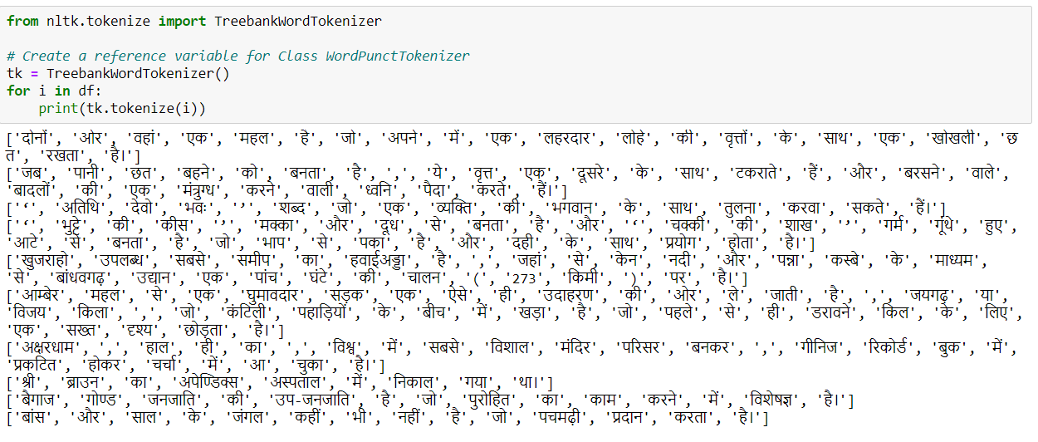

BOW

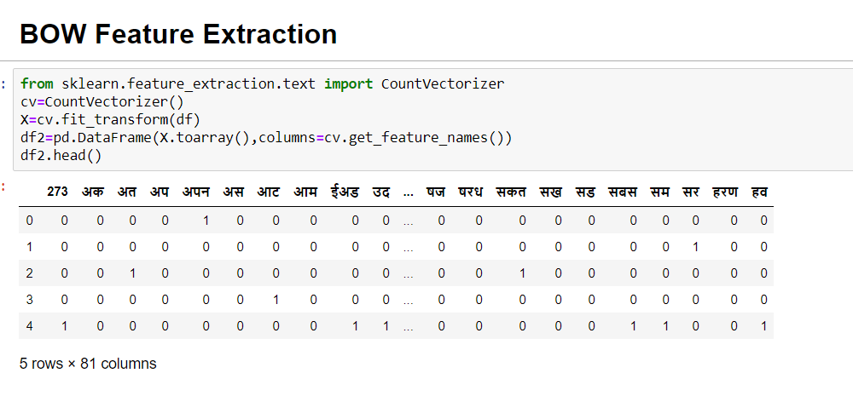

TF-IDF

